**DAILY ONLINE ACTIVITIES SUMMARY**

|  |  |  |  |  |  |  |  |  |
| --- | --- | --- | --- | --- | --- | --- | --- | --- |
| **Date:** | **26/07/2020** | | | | | **Name:** | **Spoorthy Balaji** | |
| **Sem & Sec** | **6th & B** | | | | | **USN:** | **4al17cs098** | |
| **Online Test Summary** | | | | | | | | |
| **Subject** | | **-** | | | | | | |
| **Max. Marks** | | **-** | | **Score** | | | **-** | |
| **Certification Course Summary** | | | | | | | | |
| **Course** | **Salesforce - Job ready Program** | | | | | | | |
| **Certificate Provider** | | | **-** | | **Duration** | | | **1hour** |
| **Coding Challenges** | | | | | | | | |
| **Problem Statement: Python Program for Largest K digit number divisible by X** | | | | | | | | |
| **Status: Solveds** | | | | | | | | |
| **Uploaded the report in Github** | | | | | **yes** | | | |
| **If yes Repository name** | | | | | <https://github.com/spoorthybalaji/Daily_Status> | | | |
| **Uploaded the report in slack** | | | | | **yes** | | | |

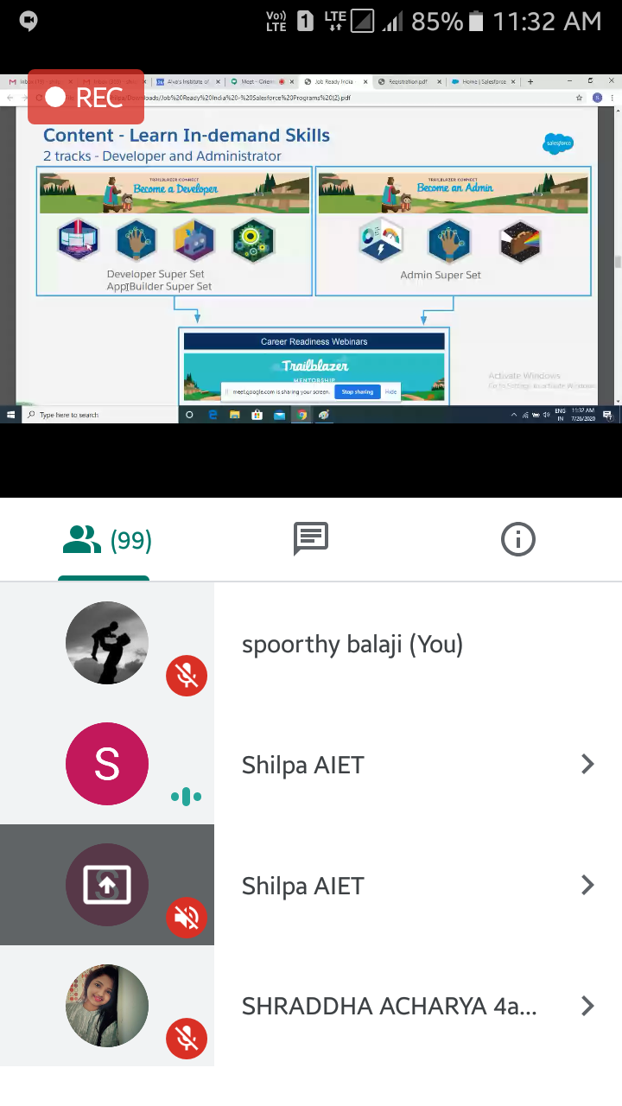

**ONLINE** **CODING**

**Python Program for Largest K digit number divisible by X**

def answer(X, K):

MAX = pow(10, K) - 1

return (MAX - (MAX % X))

X = 30

K = 3

print("The Value is:",answer(X, K))

